Jenkins Assignment 6
Creating a war file on master and uploading it to s3 bucket then downloading the war file on slave and then deploying it on tomcat
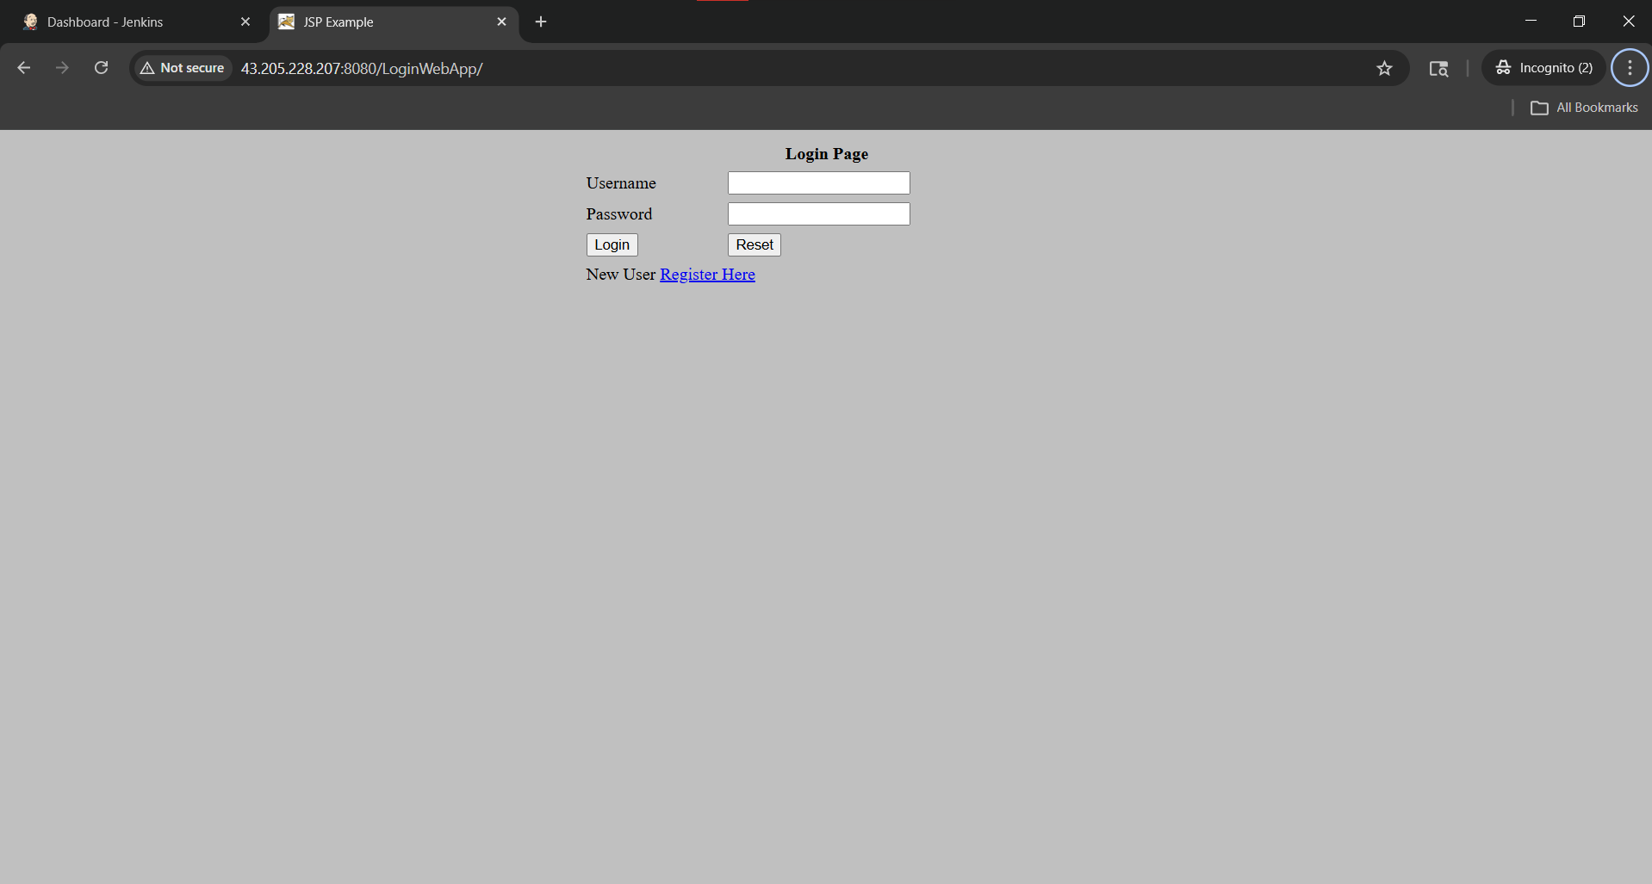

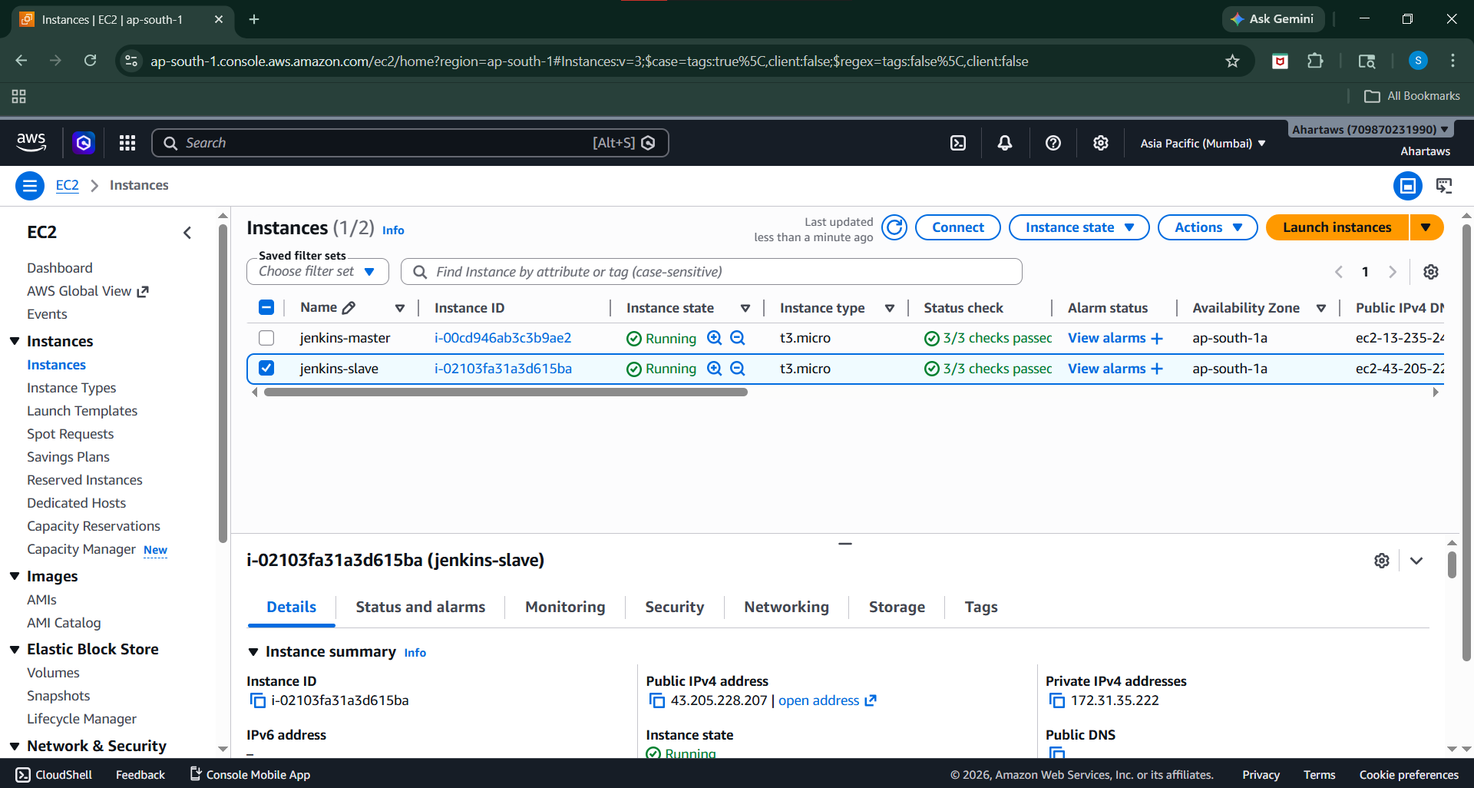

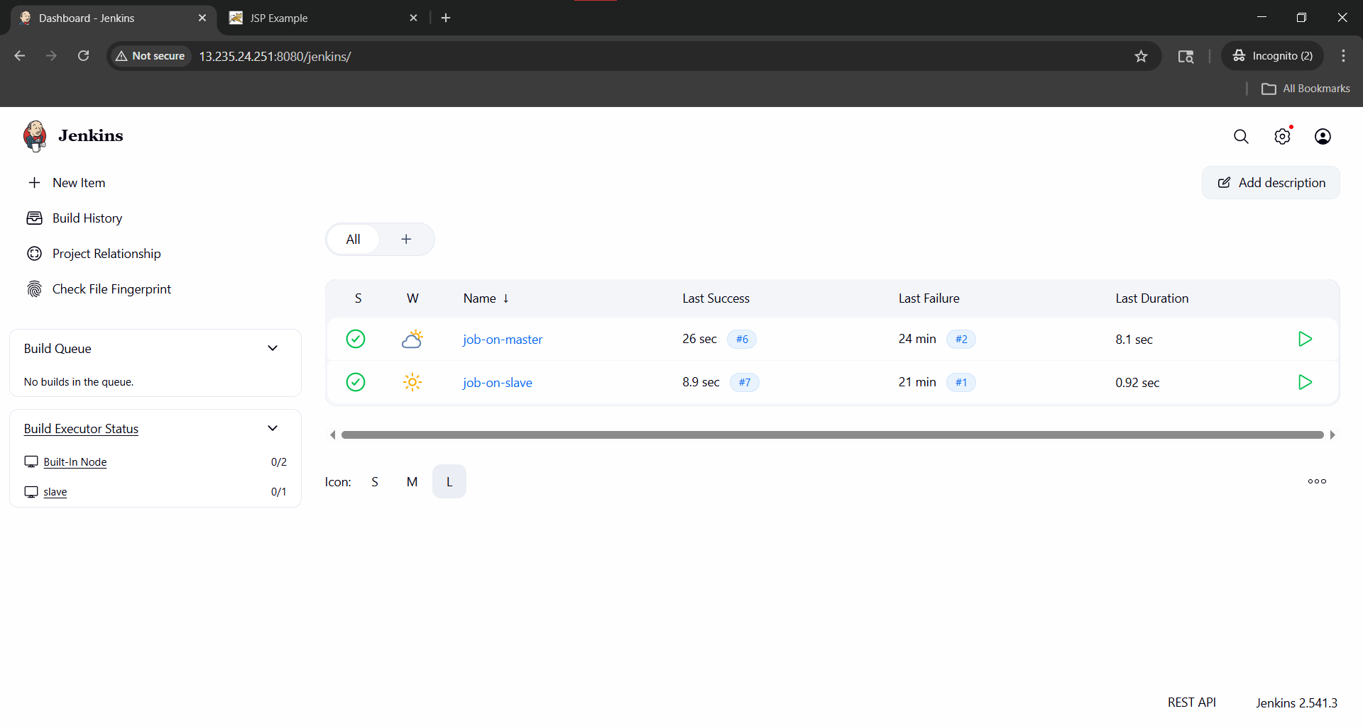

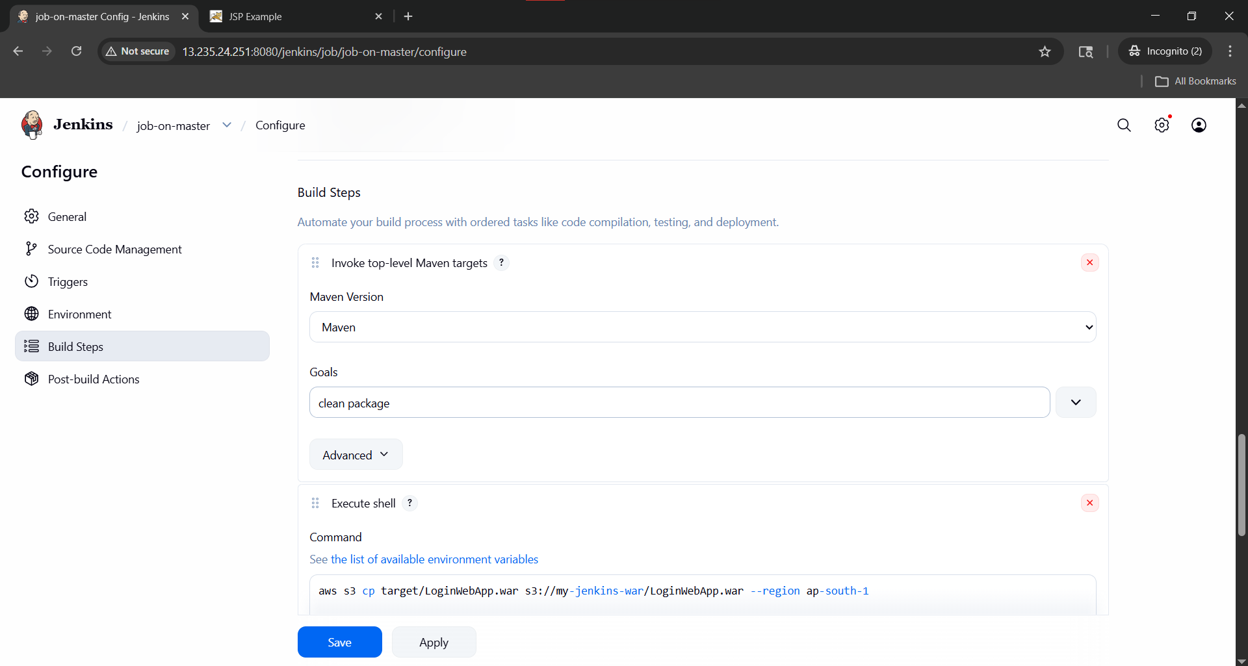

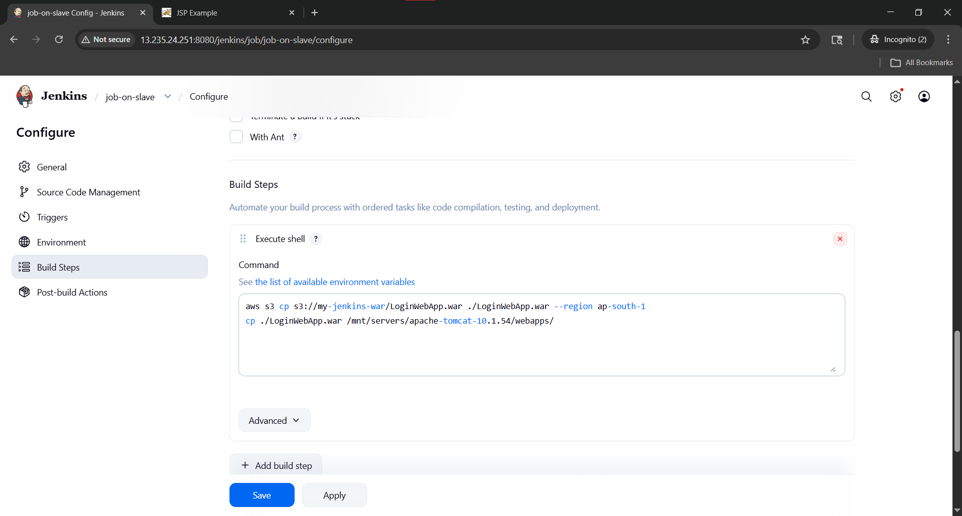

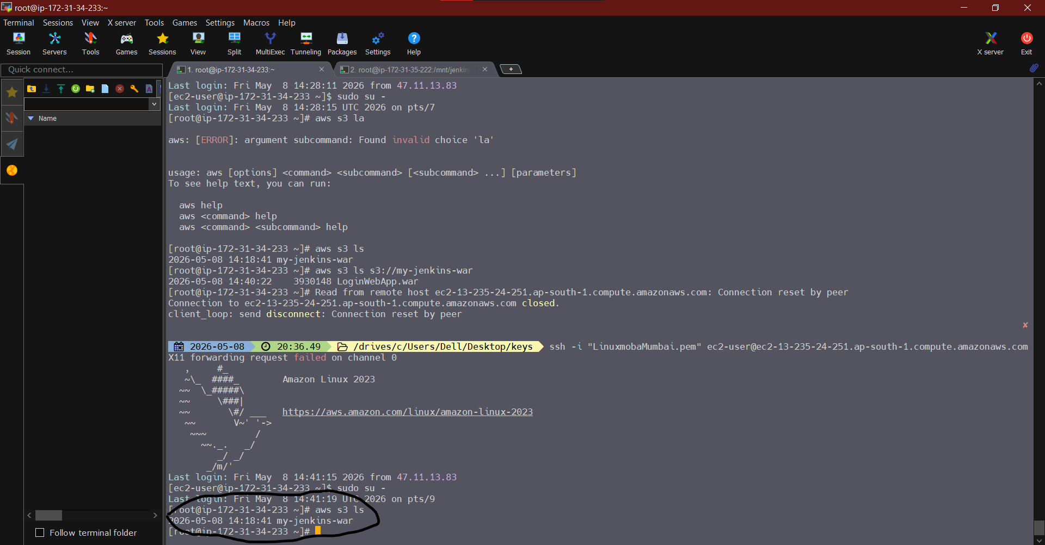
Bucket on master
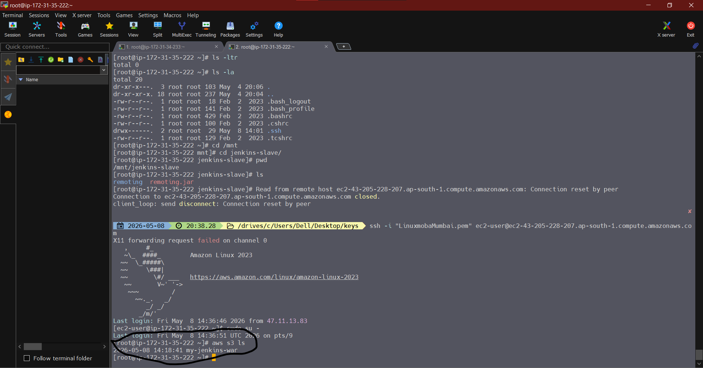
Bucket on slave
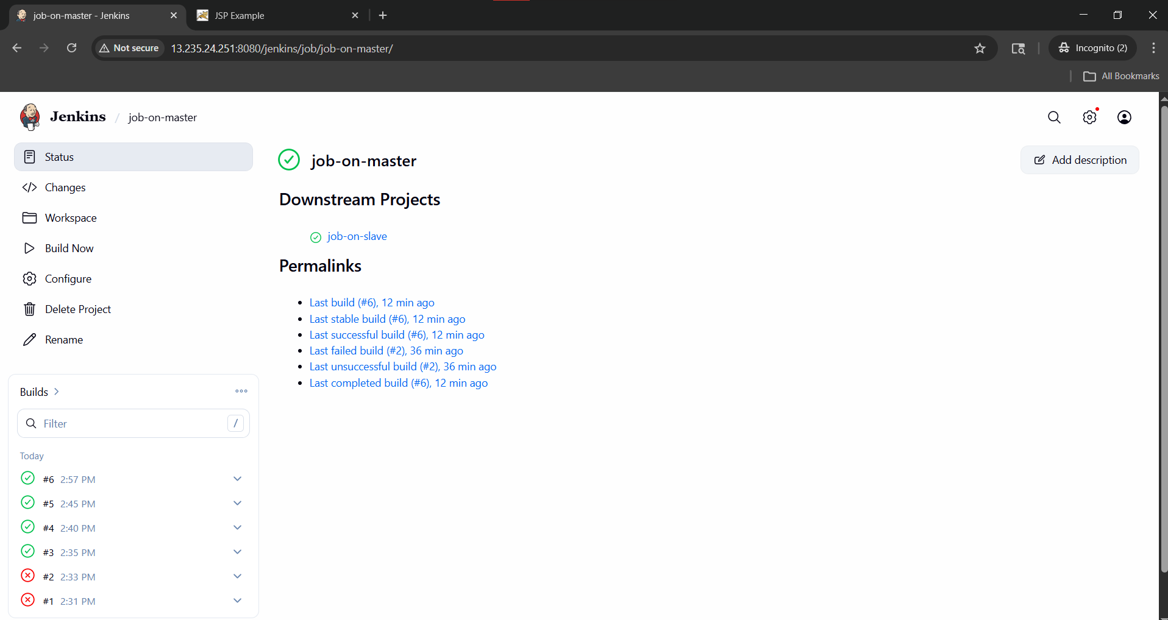

Using pipeline job
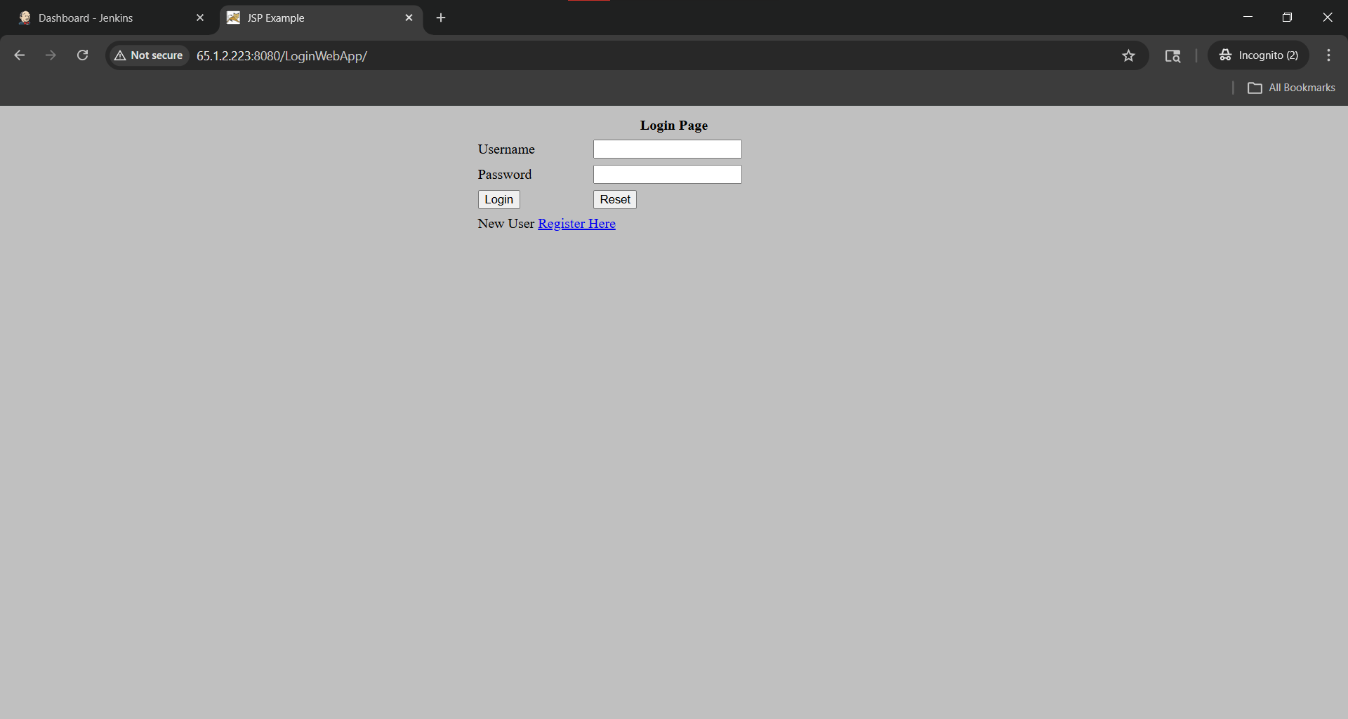
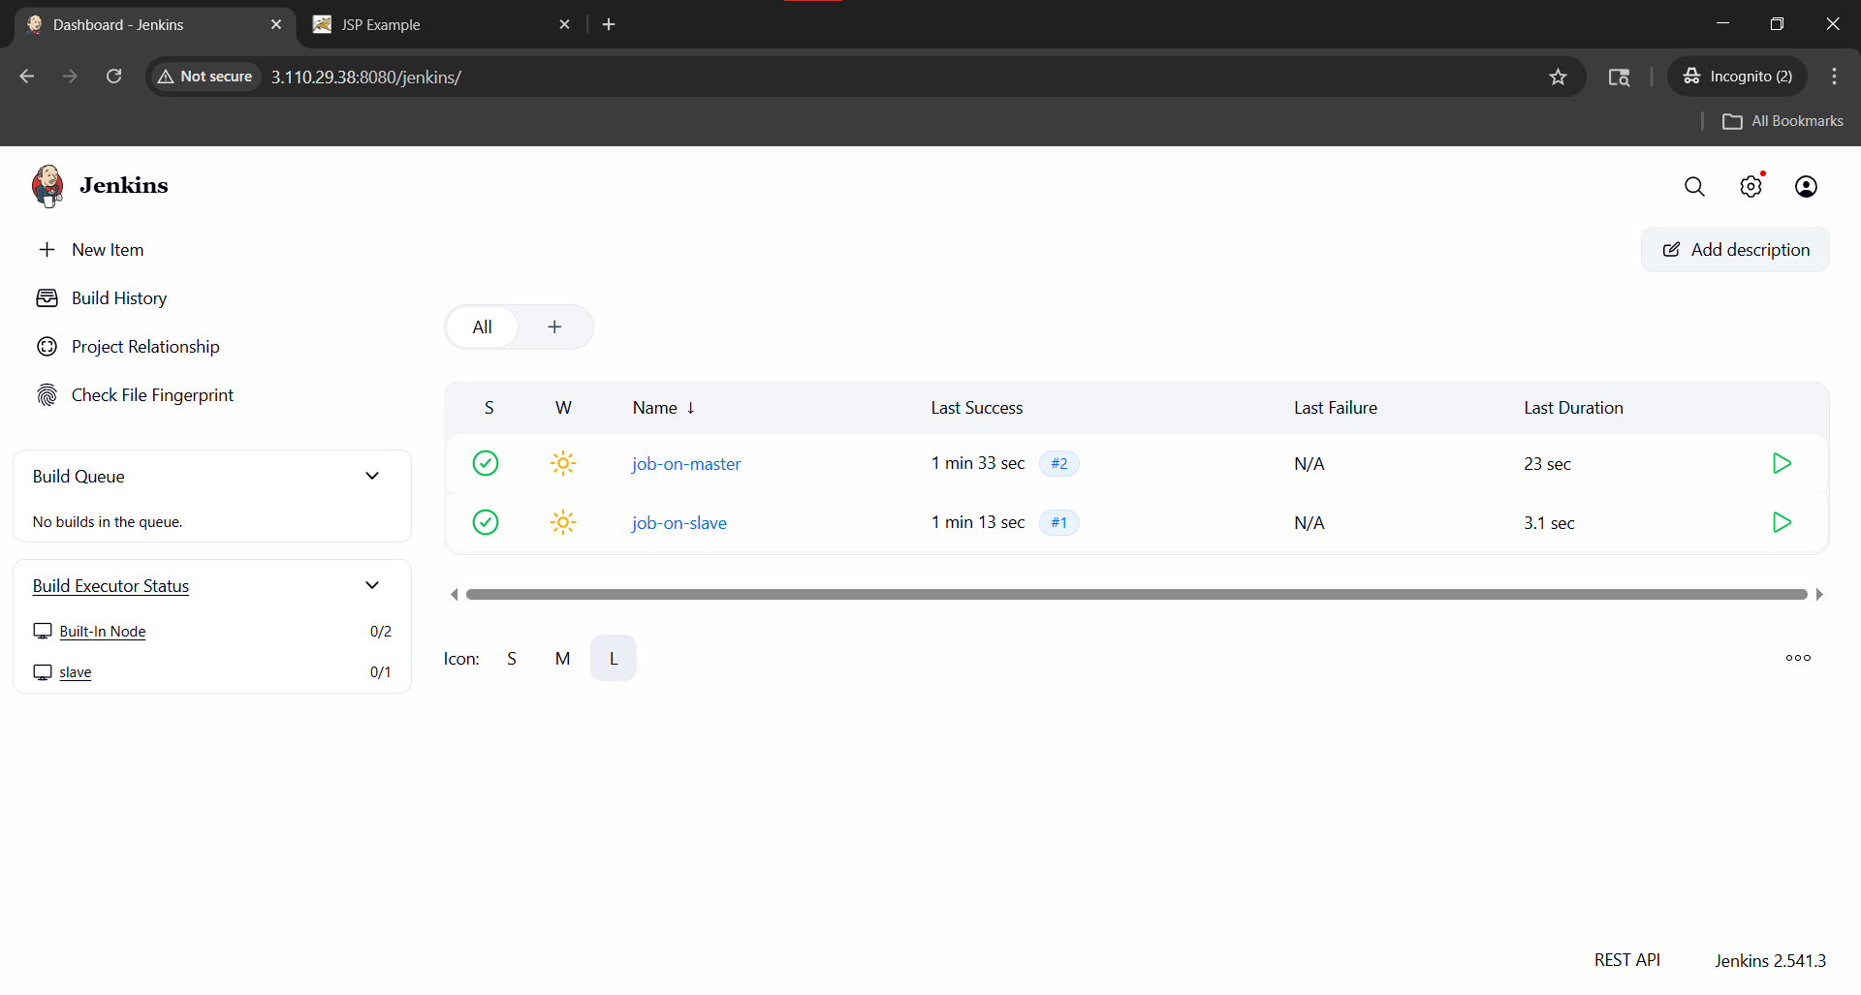

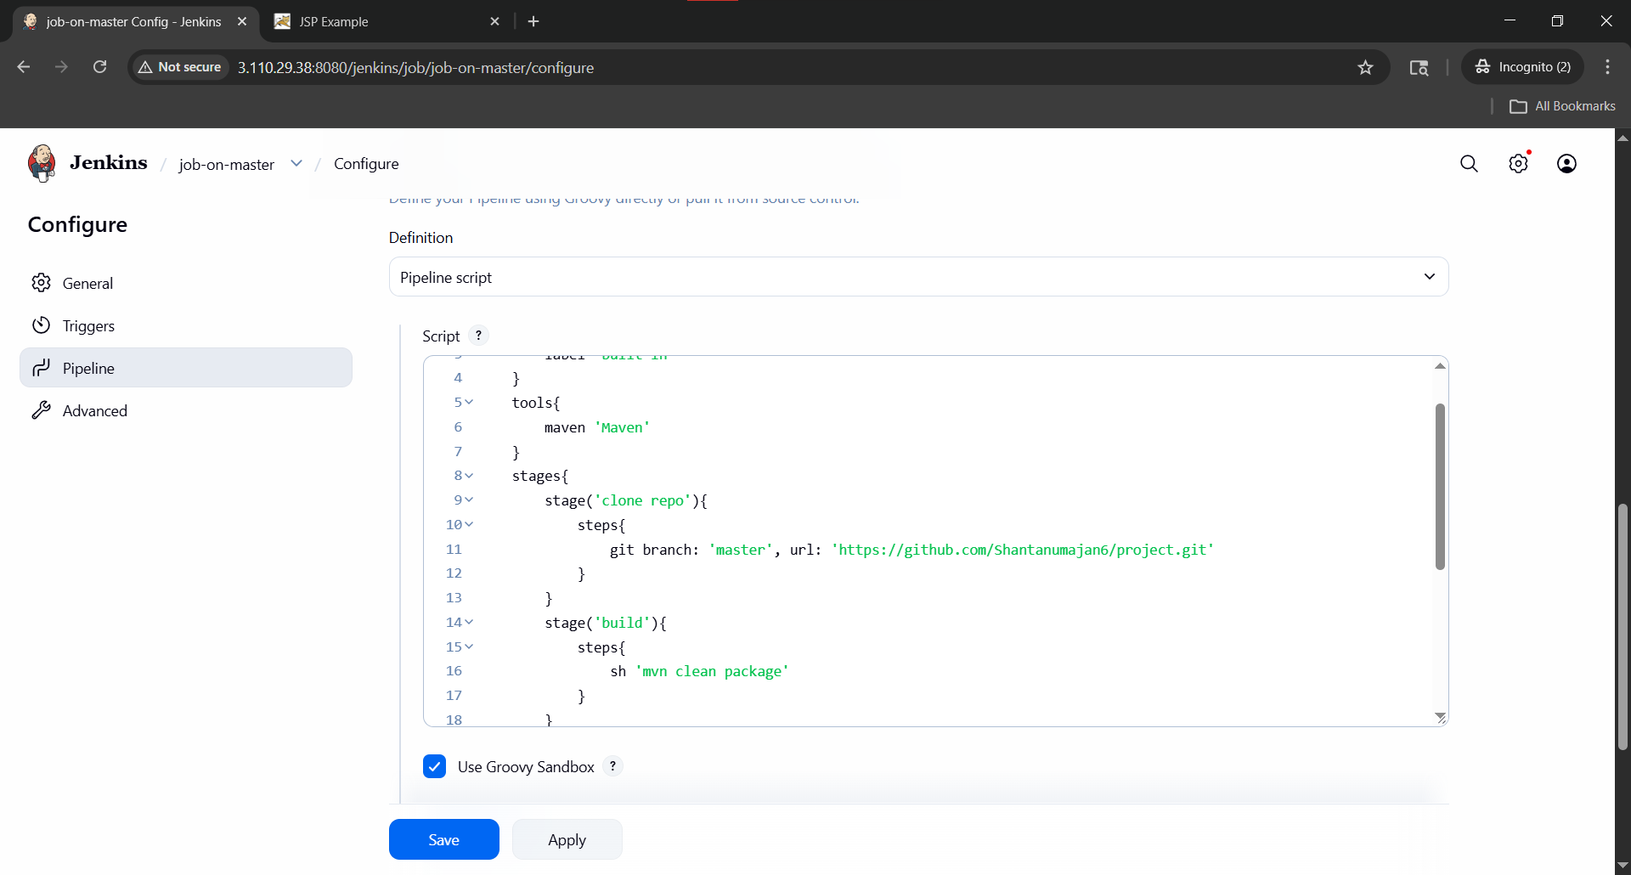

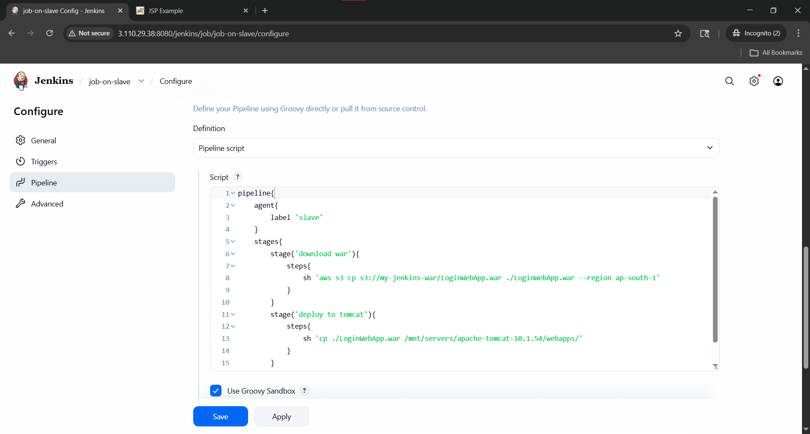
job-on-master
pipeline{
agent{
label 'built-in'
}
tools{
maven 'Maven'
}
stages{
stage('clone repo'){
steps{
git branch: 'master', url: 'https://github.com/Shantanumajan6/project.git'
}
}
stage('build'){
steps{
sh 'mvn clean package'
}
}
stage('upload to s3'){
steps{
sh 'aws s3 cp target/*.war s3://my-jenkins-war/ --region ap-south-1'
}
}
stage('trigger slave job'){
steps{
build job: 'job-on-slave', wait: true
}
}
}
}
job-on-slave
pipeline{
agent{
label 'slave'
}
stages{
stage('download war'){
steps{
sh 'aws s3 cp s3://my-jenkins-war/LoginWebApp.war ./LoginWebApp.war --region ap-south-1'
}
}
stage('deploy to tomcat'){
steps{
sh 'cp ./LoginWebApp.war /mnt/servers/apache-tomcat-10.1.54/webapps/'
}
}
}
}
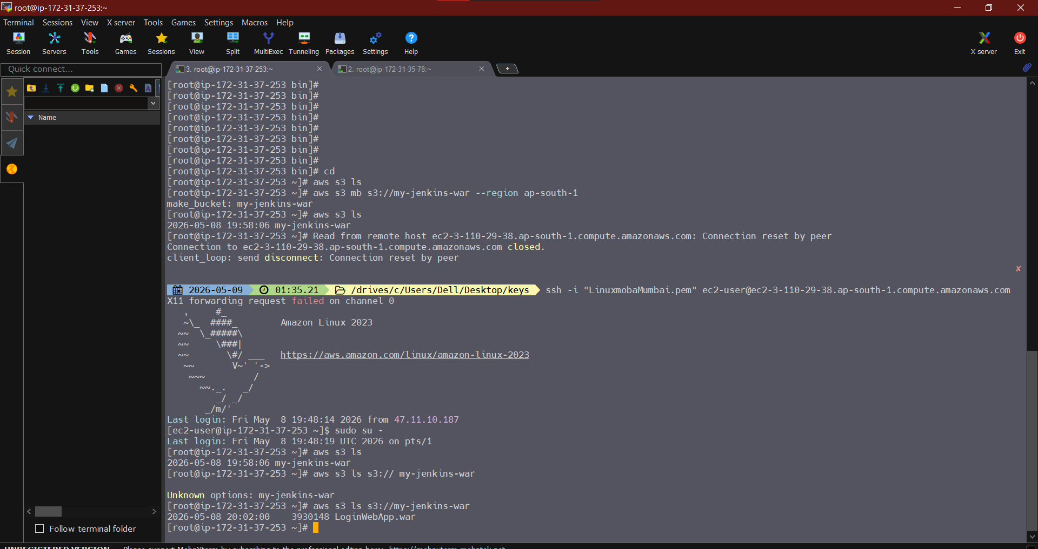
Bucket on master
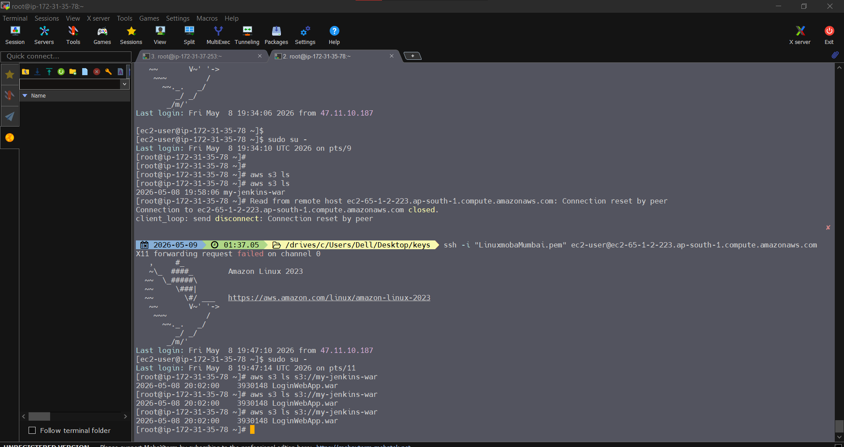
Bucket on slave

Using pipeline script from SCM
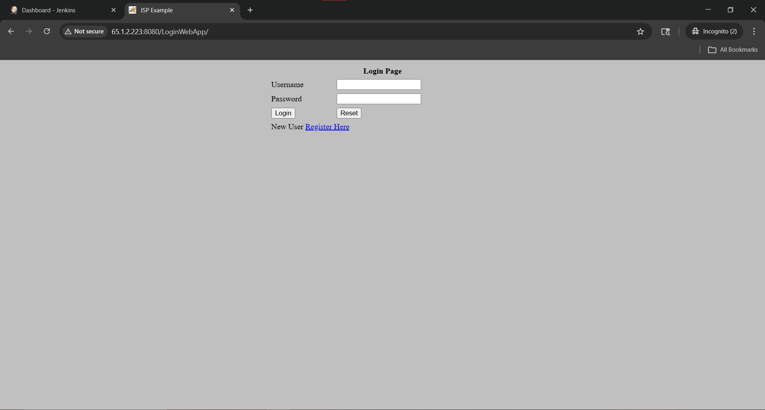
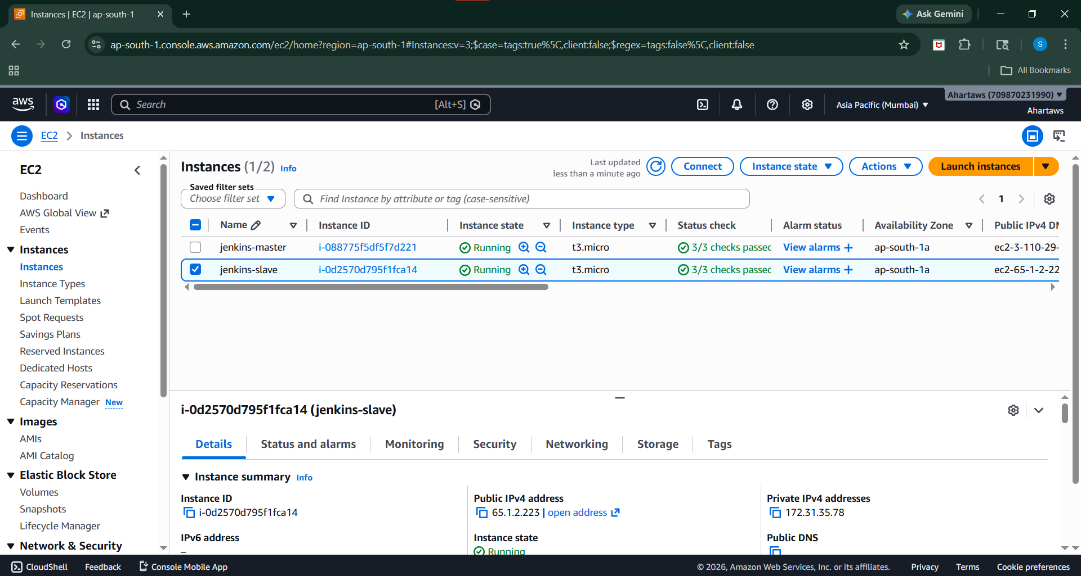
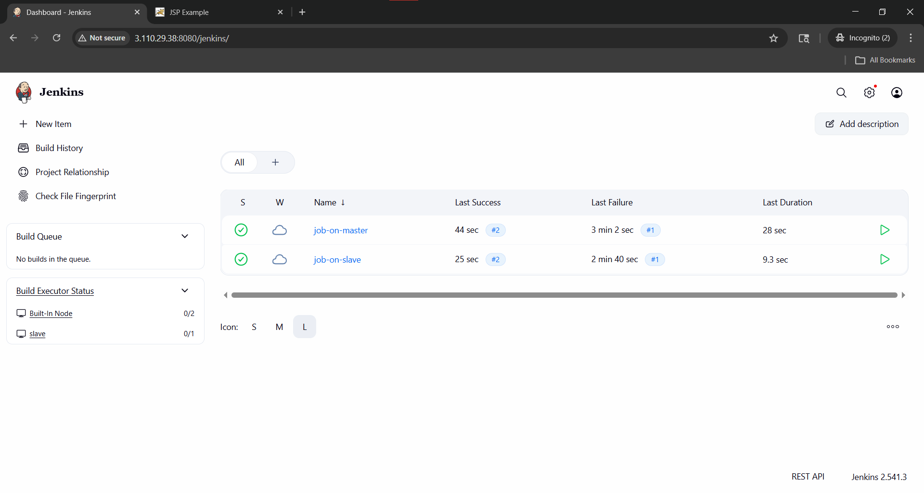

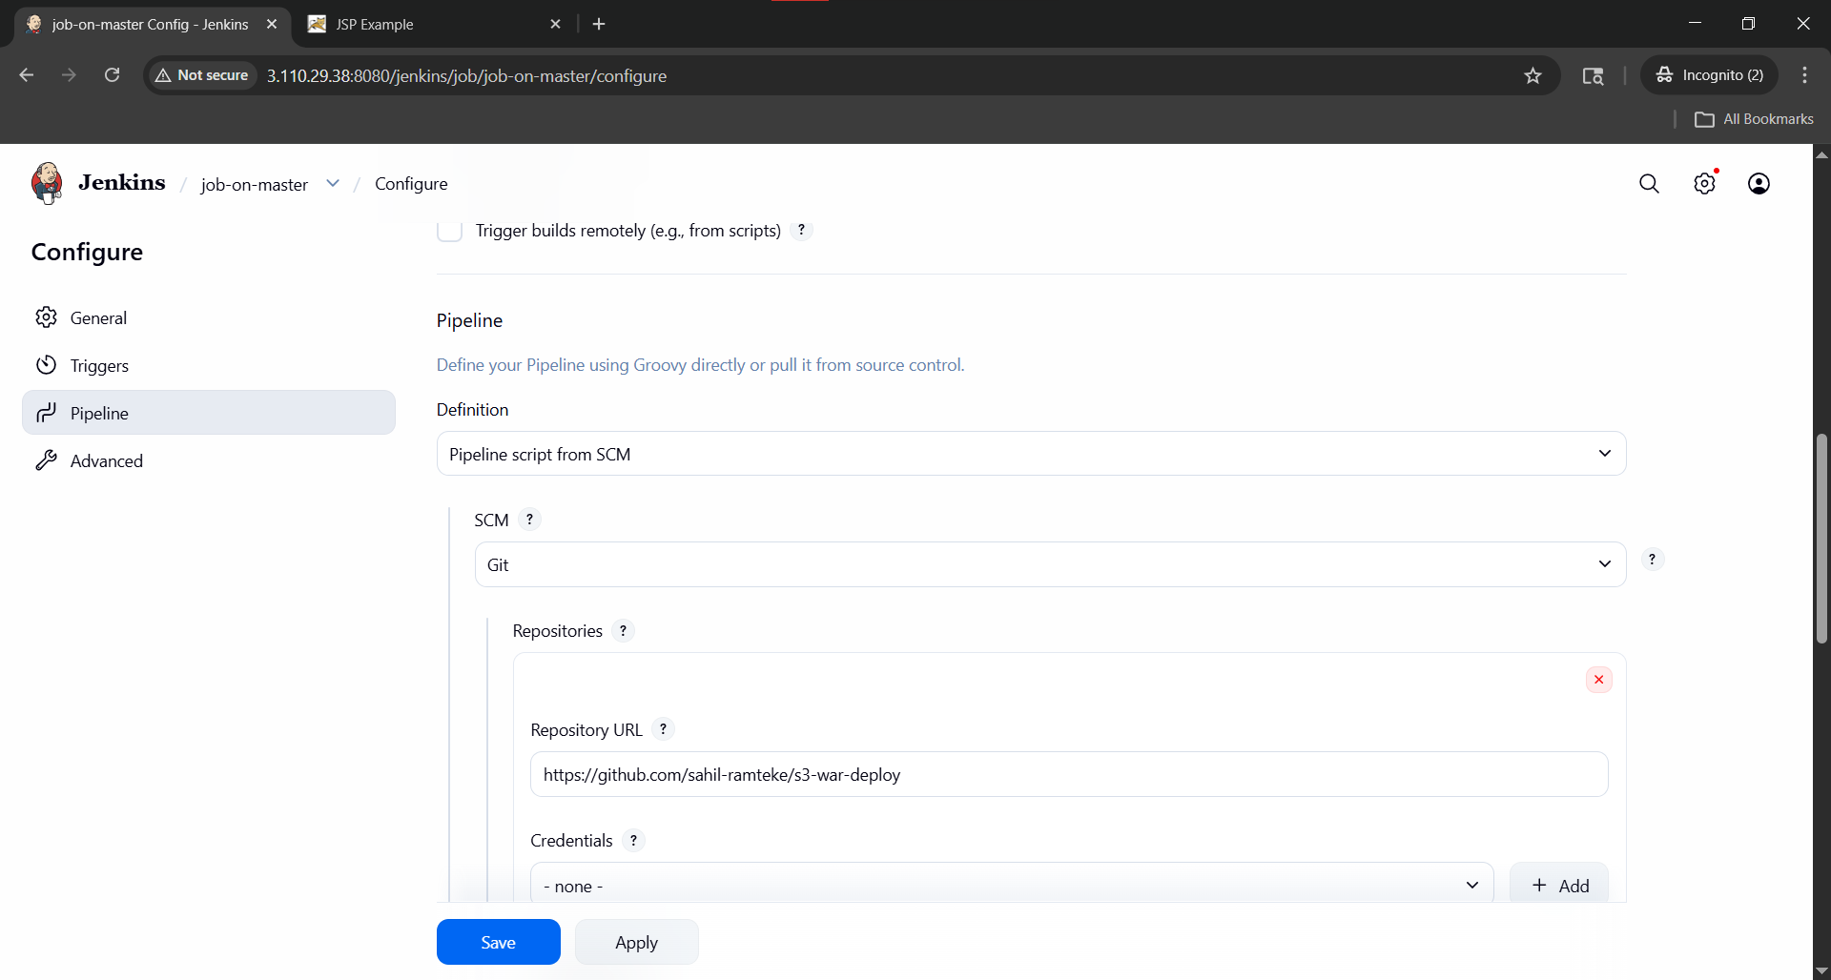
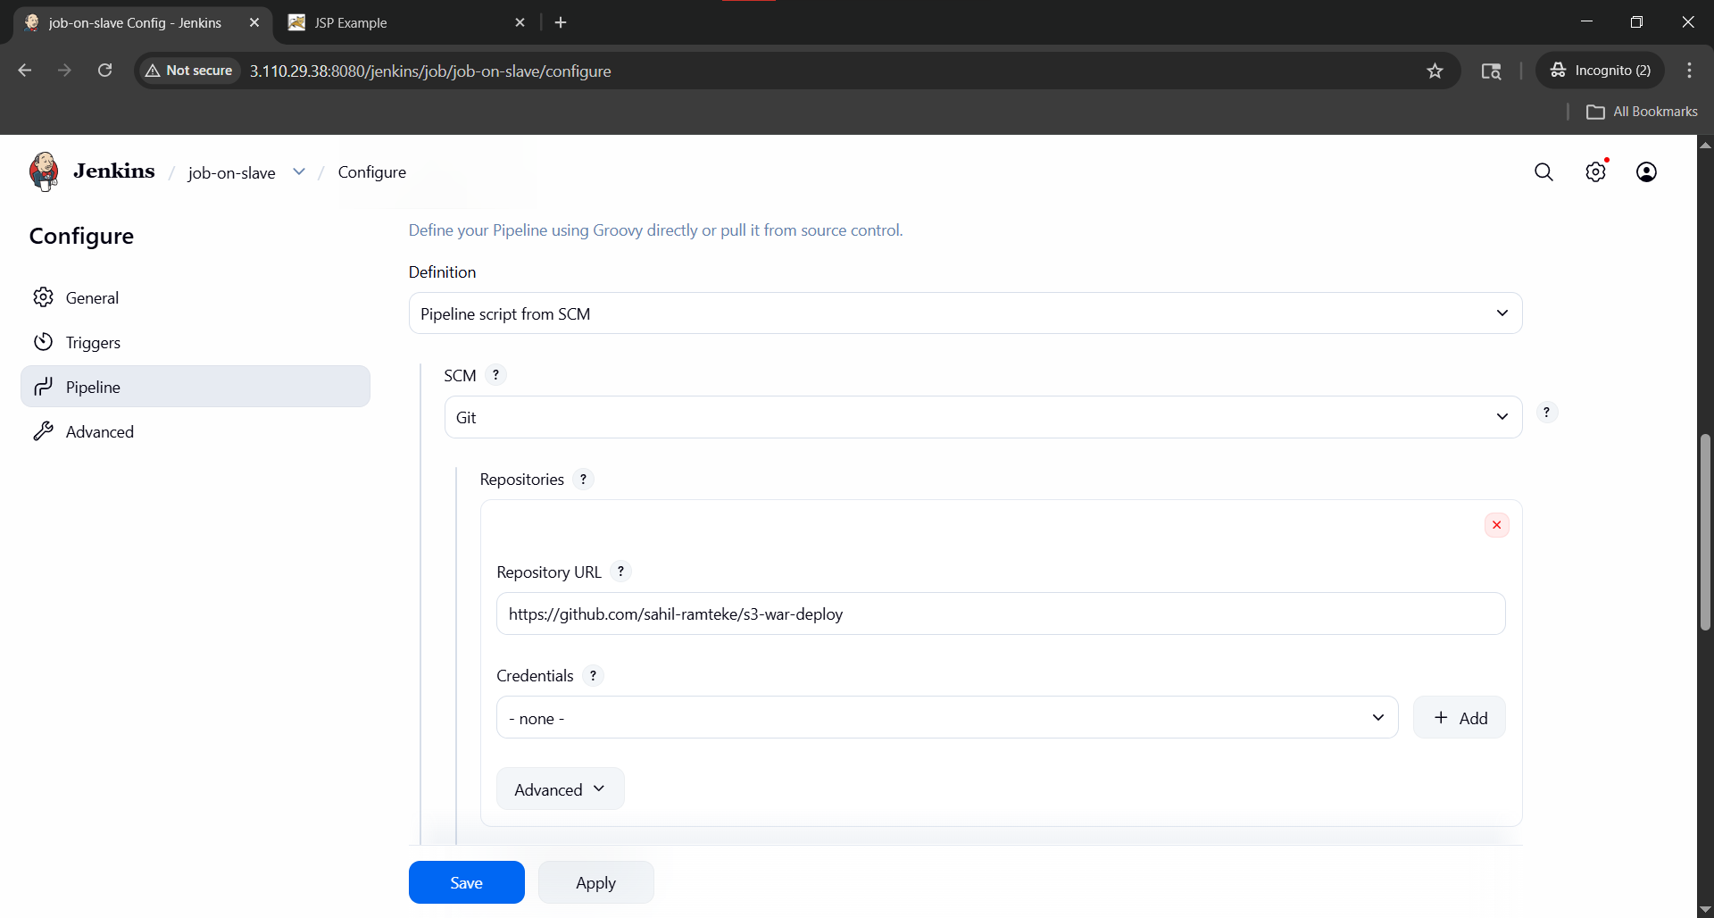

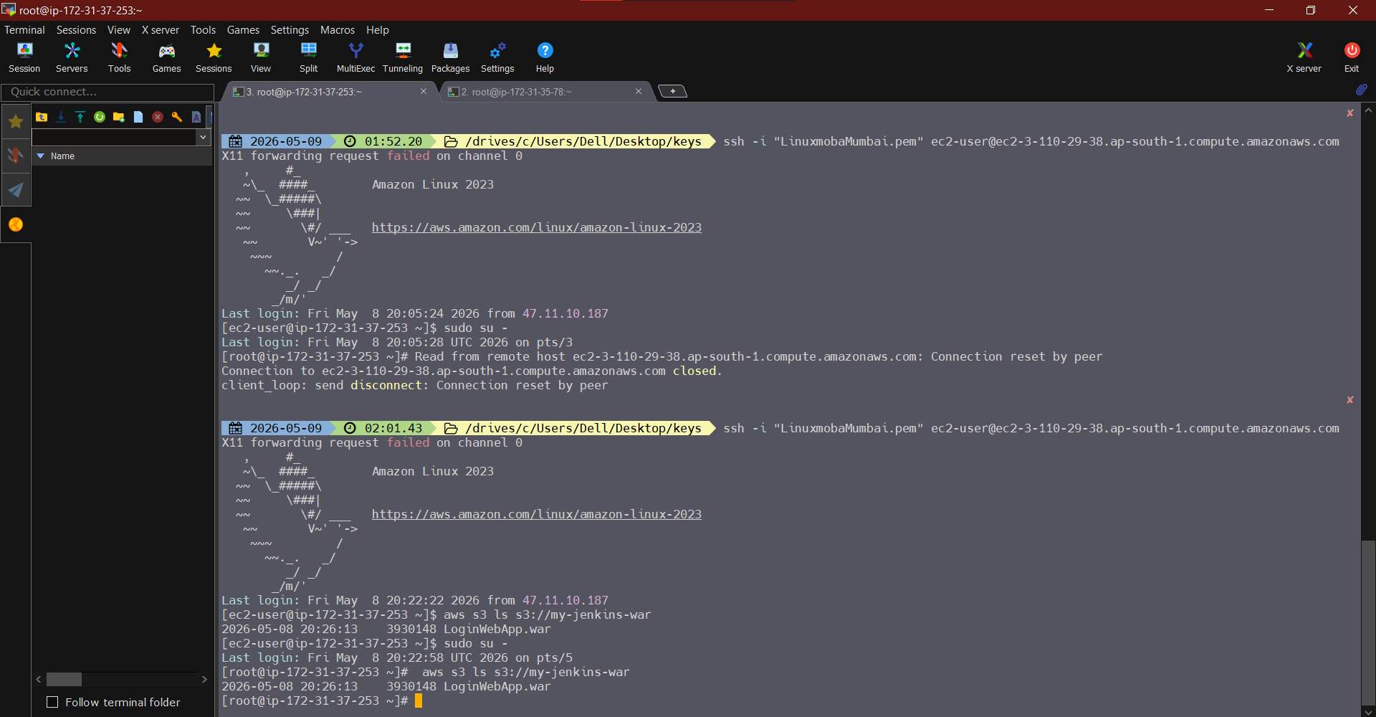
Bucket on master
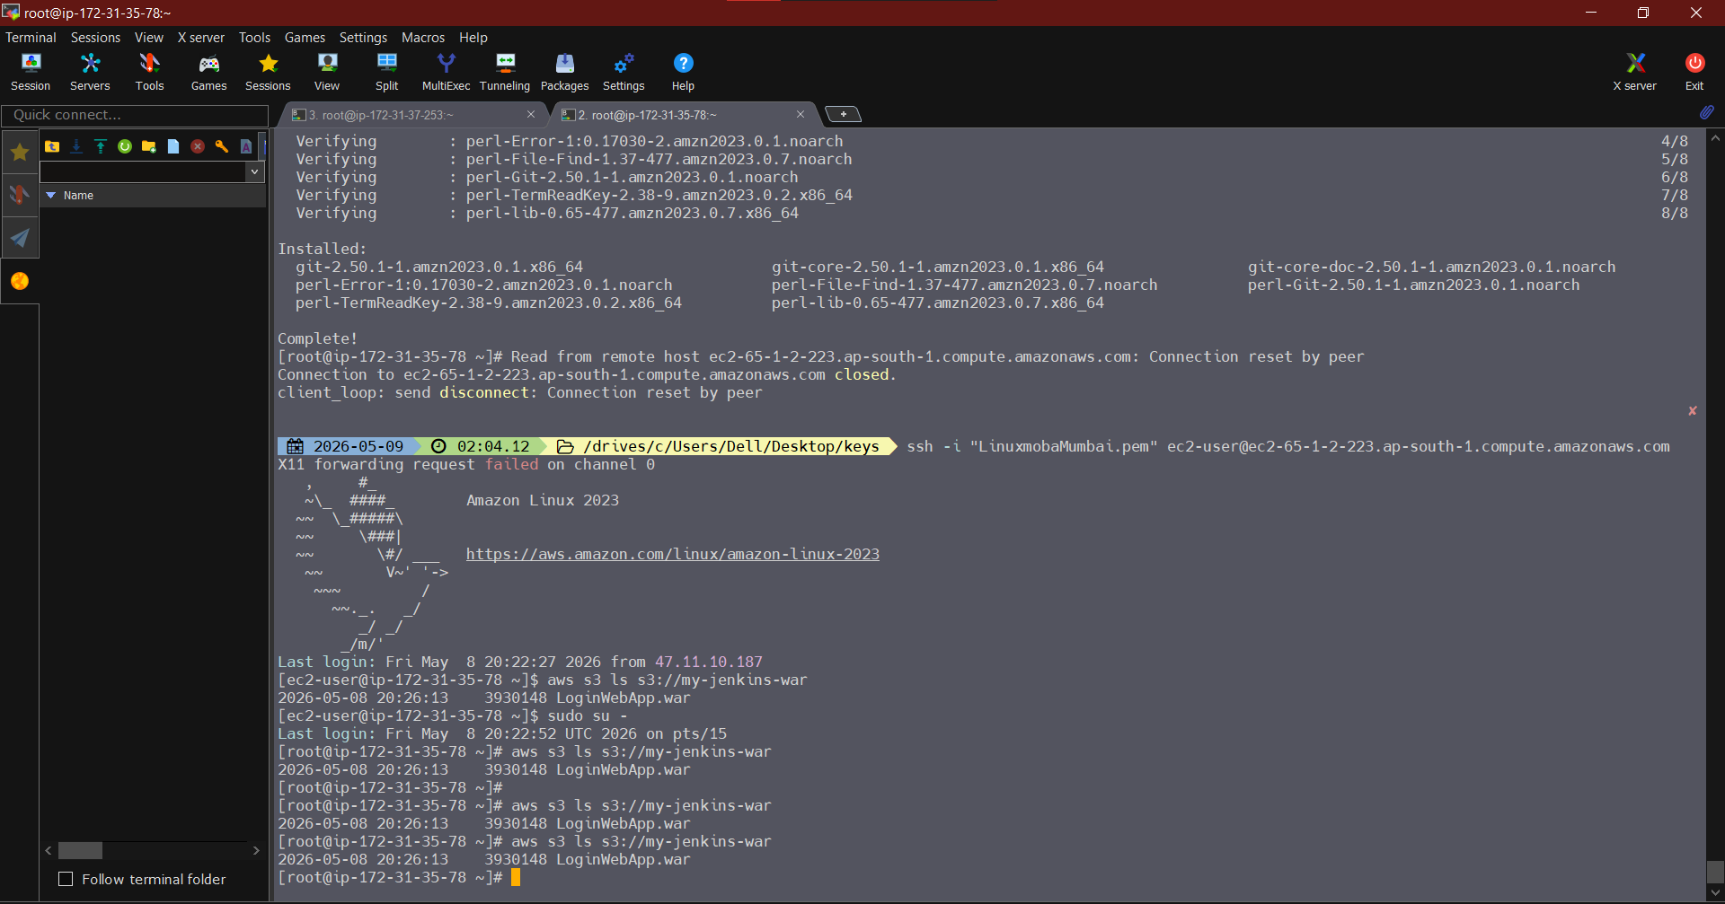

Bucket on slave

